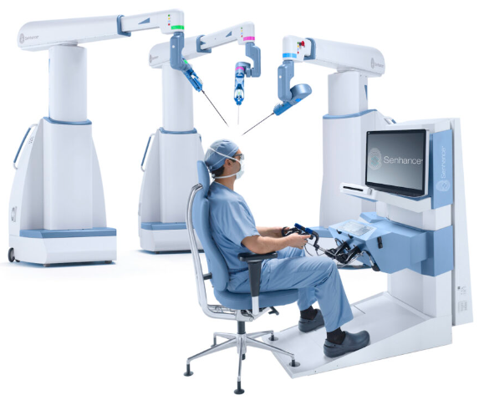

Homework 4

Gaurang Ruparelia (gr2159) | ROB-UY 3404 Haptics and Telerobotics | Date 17/12/2022

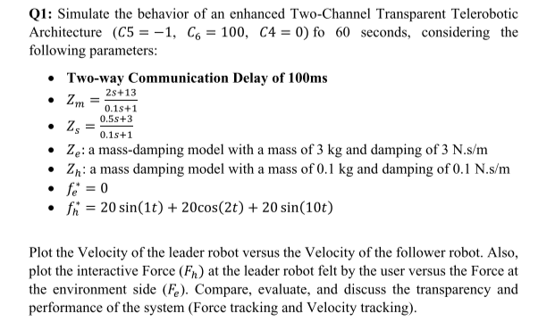

1. **Mathematically explain if you believe the system should be stable or not.**

Velocity tracking

$v_{h}$ vs $v_{e}$

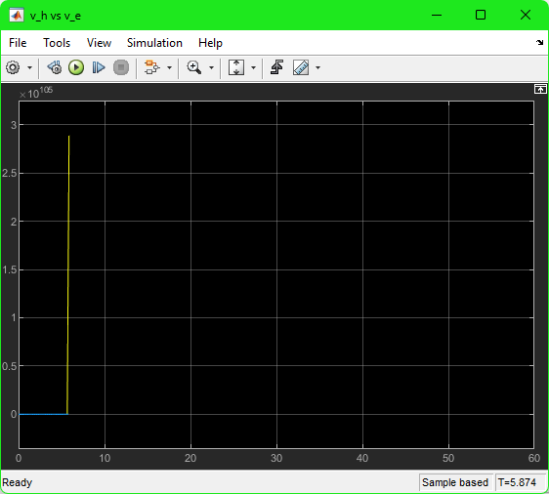

Force tracking

$f_{h}$ vs $f_{e}$

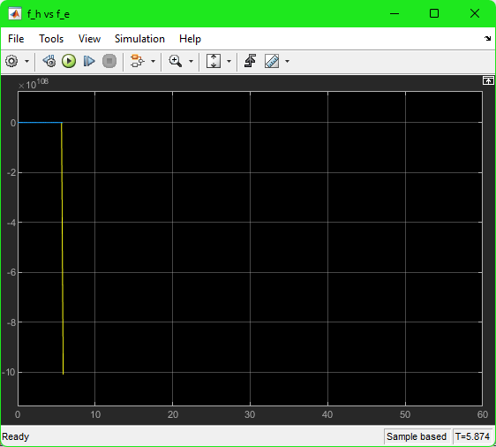

As seen in the graphs above, $f_{h}$ is tracking $f_{e}$ (same trajectory just shifted by a slight delay) as well as $v_{h}$ is tracking $v_{e}$ (same trajectory just shifted by a slight delay). This shows that the system has achieved transparency. This is expected to happen because we have configured the model to match the ideal scenario where you have kinematic correspondence ( $v_{h}$ = $v_{e}$) as well as ideal force response ( $f_{h}$ = $f_{e}$) with the exception of a delay in the curves. The system performs according to expectation because there is no echo on follower and leader side, which leads to acceptable force tracking as well as acceptable velocity tracking (ideal case for a scenario with a delay).

In order to prove stability, we can use Nyquist Stability Theory. The theory is given below

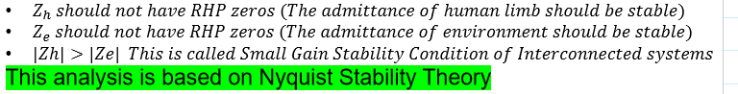

$$Z_{h}=0.1s+0.1 \\ To find zeros of Z_{h},$$

$$0= 0.1s+0.1 \\ s= -1$$

Since the zeros of $Z_{h}$ are not in the RHP, we can conclude that the first condition is satisfied.

$$Z_{e}=3s+3 \\ To find zeros of Z_{e},$$

$$0= 3s+3 \\ s= -1$$

Since the zeros of $Z_{e}$ are not in the RHP, we can conclude that the second condition is satisfied.

For the third condition,

$$Z_{h}=2jω+2 where j=\sqrt{-1} \\ \left|Z_{h}\right|=\sqrt{{\left(0.1ω\right)}^{2}+{0.1}^{2}} \\ \left|Z_{h}\right|=\sqrt{{0.01ω}^{2}+0.01}$$

$$Z_{e}=3jω+3 where j=\sqrt{-1} \\ \left|Z_{e}\right|=\sqrt{{\left(3ω\right)}^{2}+3^{2}} \\ \left|Z_{e}\right|=\sqrt{{9ω}^{2}+9}$$

$$\sqrt{{0.01ω}^{2}+0.01}<\sqrt{{9ω}^{2}+9} =\left|Z_{h}\right|<|Z_{e}|$$

Therefore, the third condition has shown to have failed the satisfaction criteria. **The system is unstable.**

1. Apply Wave-Variable control approach. Is the system stable? Explain why. Choose a value of “b” of your choice that reduces the force tracking error (submit new Simulink file). Explain your choice. Plot the Velocity of the leader robot versus the Velocity of the follower robot. Also, plot the interactive Force (𝐹ℎ) at the leader robot felt by the user versus the Force at the environment side ( 𝐹𝑒). Now choose a value of “b” of your choice that reduces the velocity tracking error (submit new Simulink file). Explain your choice. Now, compare, evaluate, and discuss the transparency and performance of the system for both values of “b” and Explain your observations.

**Apply Wave-Variable control approach. Is the system stable? Explain why.**

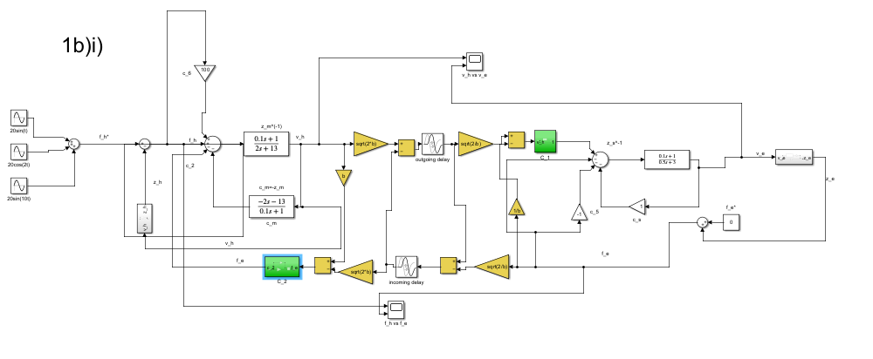

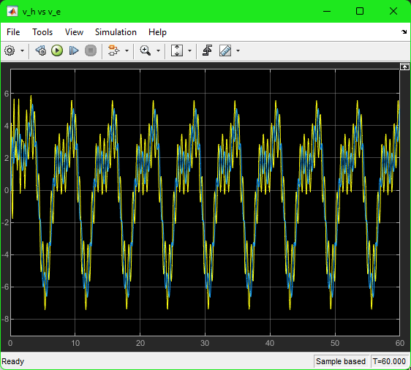

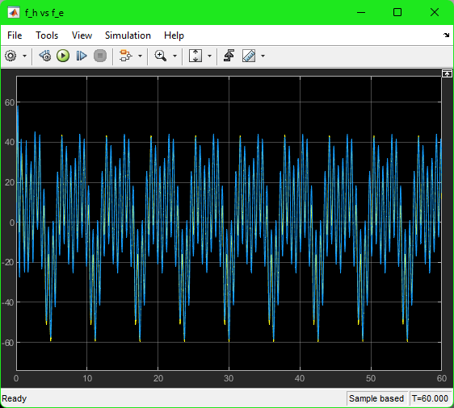

Yes, the system is stable. As seen in the graphs above, both the force and velocity graphs show oscillatory behavior and do not diverge. Therefore, the system is passive and dissipates energy over a period of time. This makes the system stable.

**Choose a value of “b” of your choice that reduces the force tracking error (submit new Simulink file). Explain your choice.**

The value of b chosen is 0.01. By experimenting with different values of b some higher some lower, it was discovered that lower values of b reduced force tracking error and improved its transparency, however, increased velocity tracking error and worsened its transparency. An informal proof below shows how force is independent of b and makes the delayed force from the environment match the force from the environment.

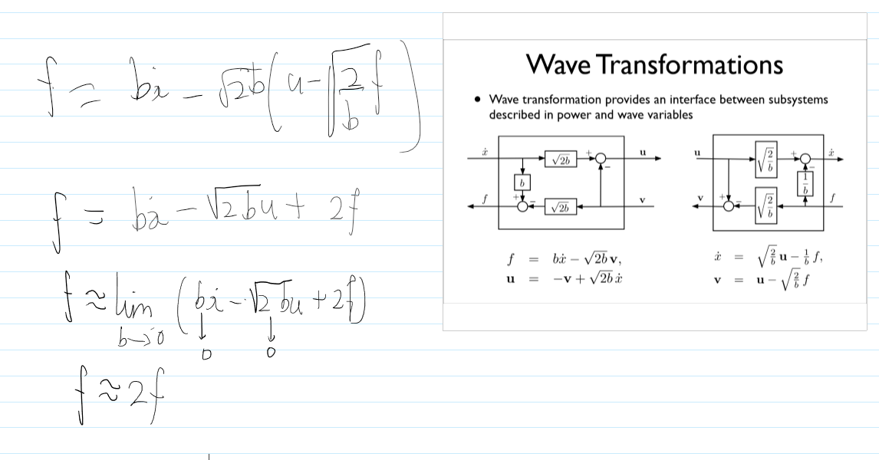

Velocity tracking

$v_{h}$ vs $v_{e}$

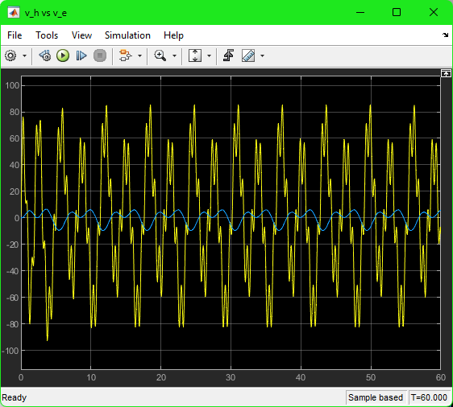

Force tracking

$f_{h}$ vs $f_{e}$

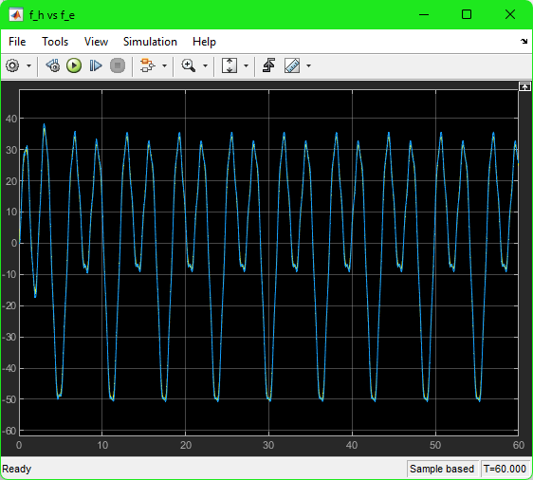

**Now choose a value of “b” of your choice that reduces the velocity tracking error (submit new Simulink file). Explain your choice.**

The value of b chosen is 10000. By experimenting with different values of b some higher some lower, it was discovered that higher values of b reduced velocity tracking error and improved its transparency, however, increased force tracking error and worsened its transparency. An informal proof below shows how velocity is independent of the inverse of b and makes the delayed force from the environment match the force from the environment.

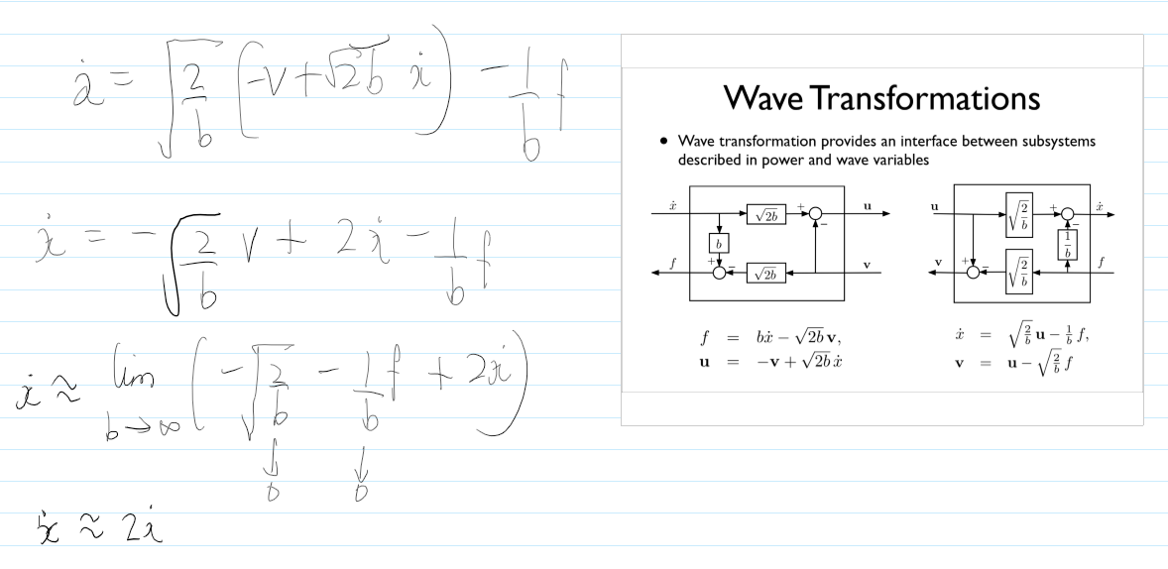

Velocity tracking

$v_{h}$ vs $v_{e}$

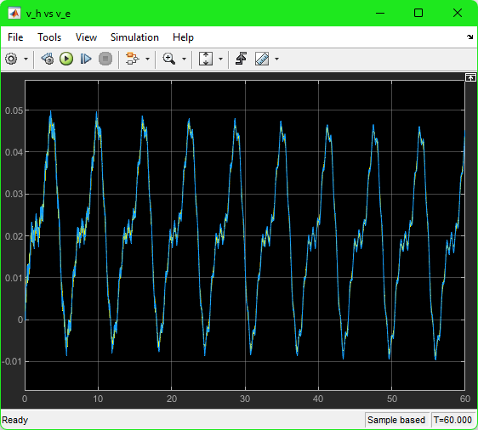

Force tracking

$f_{h}$ vs $f_{e}$

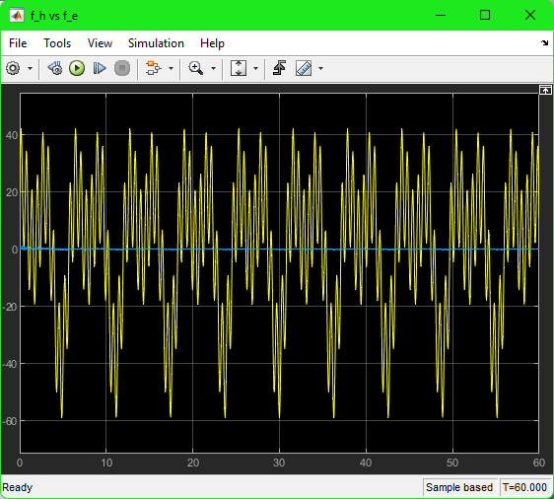

**Now, compare, evaluate, and discuss the transparency and performance of the system for both values of “b” and Explain your observations.**

For low values of b (b=0.01), it is seen in the above graphs that there is better force tracking, $f_{h}$ is tracking $f_{e}$ (same trajectory just shifted by a slight delay) but very poor velocity tracking $v_{h}$ is not tracking $v_{e}$. This shows that the system has achieved ideal force response ( $f_{h}$ = $f_{e}$) with the exception of a delay in the curves. This is expected to happen because we have configured the model to have a small b which boosts the transparency of force but reduces the transparency of velocity.

For high values of b (b=10000), it is seen in the above graphs that there is better velocity tracking, $v_{h}$ is tracking $v_{e}$ (same trajectory just shifted by a slight delay) but very poor force tracking, $f_{h}$ is not tracking $f_{e}$. This shows that the system has achieved kinematic correspondence ( $v_{h}$ = $v_{e}$) with the exception of a delay in the curve. This is expected to happen because we have configured the model to have a large b which boosts the transparency of velocity but reduces the transparency of force.

All things considered, we see that there is a tradeoff to be made between force tracking and velocity tracking by selecting a value for b.

1. **If the delay was changing by time, can we still say that the system would remain stable? If yes, why? If no, Why? If any change would be needed to guarantee stability of a time-varying delay, please explain.**

When communication delay is a function of time (varying), passivity can be lost even in wave variables domain. Stability for constant time delay does not imply stability for time-varying delay. The distortion of wave signals due to time-varying communication delay may introduce energy into the communication block, which makes it non-passive and, therefore, unstable. One possible way to dissipate the excess energy is by appropriate scaling of wave variables. This method, called Passivation by Scaling the Wave Variables, was devised by (Lozano et. al., 2002).

Passivation by Scaling the Wave Variables involves distinguishing between outgoing delay by multiplying it by a gain, $g_{1}$, and incoming delay by multiplying it by a gain, $g_{2}$.

There are 2 main assumptions to consider in this scenario:

1. Restricting the value of rate of change of delay
$${\dot{T}}_{i}^{2}<1=\frac{dT_{i}}{dt}<1; i=1, 2$$

2. Restricting the value of square of incoming gain and square of outgoing gain

$$g_{i}^{2}≤1-{\dot{T}}_{i}^{2}; i=1, 2$$